ComUUnicator
The Newsletter of the United Unitarian Universalist Congregation
Waukesha, Wisconsin
December 2015
506 N. Washington Avenue  Waukesha, WI 53188  262-544-1050  www.UnitedUUC.org |  | 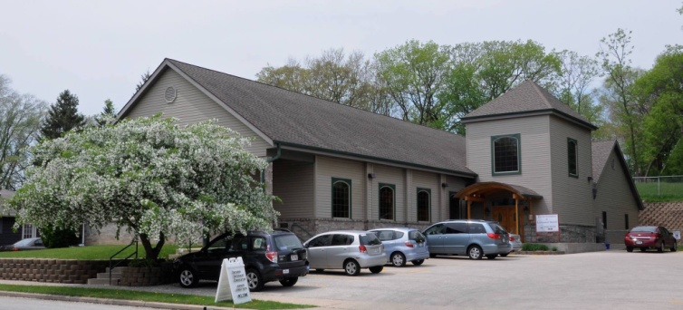 |  | OFFICE HOURS  Tuesday & Friday  9am – 3pm  MINISTER’S HOURS  Tuesday 10am-12pm  Friday 10am – 2:00 pm
United Worship Services
Every Sunday at 10:30 AM

December 6, 2015 “ The Real Great Surprise” Speaker: Rev. Schuyler Vogel

Chanukah is known as the Festival of Lights, often remembered as a celebration that single oil light lasted eight full days. But the real miracle of the holiday, and why it is remembered at all, was the unexpected victory of the Maccabees. We’ll talk about that was so surprising, what it means, and how this Chanukah story of expectation and perseverance can matter today.

December 13, 2015 Christmas Multigenerational Speakers Rev. Schuyler Vogel and
DRE, Darlyn Buelow
Come join us for a service for all ages featuring holiday singing, stories and celebration. We'll get into the holiday spirit with this lively and fun worship.

December 20, 2015 Winter Solstice Guest Speaker: Meg Whaley

The hymn, "Dark of Winter" by Shelley Jackson Denham has become my favorite Winter hymn. "Dark of Winter, soft and still, your quiet calm surrounds me." We can use the darkness to gather our energy back to ourselves. We can restore - physically, spiritually, and emotionally. It's a time to get still and listen to our intuition. And in so doing, we allow the peace of this time to flow through us in anticipation of a new beginning. In this Winter Solstice service, we will honor both the dark and the light.

December 24 , 2015 at 4:00PM Christmas Eve service Speaker: Rev. Schuyler Vogel

December 27, 2015 “Planning the Present Moment” Guest Speaker: Mike Zinke

The basic teaching of Zen and Mindfulness stress living in the present moment. But if we are always in the present moment; how do we plan for the future?

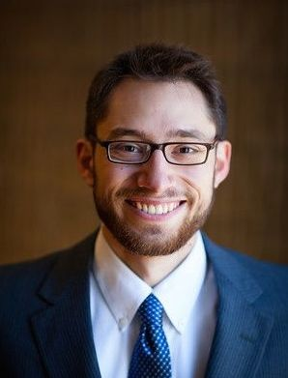 | Rev. Schuyler Vogel  minister@uniteduuc.org  262-544-1050 |  | Office hours  Tuesday 10am to 12pm  &  Friday 10am to 2pm

Religious Education
Darlyn Buelow, Director of Religious Education
Thanks to everyone who has signed up to help so far this year! Spirit Play is fully under way and going well. See the signup sheet for any volunteer openings.
I will have December Religious Education lessons listed in the Order of Service for each week and in the weekly announcements as I have them available.

SEPTEMBER NEWSLETTER DEADLINE:

Treasurer’s Report

TREASURER'S REPORT for 2015-16 Fiscal Year
Income |  | Amounts from |  | Amount Budgeted for the
 |  | 7/1/15 - 11/13/15 |  | Year 7/1/15- 6/30/16
 | Pledges | $26,137 |  | $69,350
 | Other Income | $7,563 |  | $41,666
 | Total Income | $33,700 |  | $111,016
Total Expenses |  | 39,266 |  | $104,484
Income - Expenses |  | ($5,566) |  | $6,532
Endowment Balance on 10/31/15 is $215,120
Mortgage Balance on 11/1/15 is $146,717
THREADS UNITED

We will meet on Wednesdays, December 2nd & 16th at
9:30 AM at Marcia’s home

United Used Jewelry Fundraiser

The holidays will be here before you know it!

After the service on Sunday, December 6th, United will have a USED JEWELRY SALE—a fun and reasonable way to find holiday gifts for yourself and others!

This is a small fundraiser for our congregation and will be held in the fellowship hall after church. Donations will be gladly accepted in the office on Tuesdays and Fridays between 10 AM and 2 PM as late as Friday, December 4th.

Thank you!

SOCIAL ACTION COMMITTEE NEWS

Can you help your neighbors get affordable health care coverage?
The answer is yes - by sharing the following information:
* Enrollment for insurance is open from now until January 31,2016
* If you need live person assistance you can so by going to www.healthcare.gov. Click the link for "Find local help"
*Waukesha County provides free advice and assistance by contacting a benefits specialist at 262-548-7848
*If you are a member of a group, whose members might need help, Citizen Action of Wisconsin will provide trained volunteers to address a group of any size with assistance. Please call Kevin Kane at 414-550-8280 for more information
*Every insurance agent is required by law to help you sign up for free for the best insurance you can afford

Please also remember:
*There is still a Coat Drive barrel in the vestibule for donations till mid December. Please think of us when you clean your closets for fall!

*We are still collecting non-perishable food for the Food Pantry as well as underwear, socks and toiletries. You will find the barrel and baskets in the vestibule. Your donations are very much appreciated!

December POTLUCK is Sunday, December 13

This month’s potluck is “ Holiday Brunch” and is featuring baked egg dishes, sliced baked ham, sausages, fruit, holiday breads ....all manner of holiday brunch treats.

The Sign- up sheet is in the fellowship hall. Call or email Kaye Wickenberg for more information about what we need.

POTLUCK SCHEDULE FOR 2015-2016
SECOND SUNDAY EACH MONTH

MONTH &THEME

December 13: Holiday Brunch

January 10: Chili lunch

February 8: Soup and sandwich

March 13: Potato special

April 10: Mexican fiesta

May 15: Salad Day (Mother’s Day is on May 8, so Potluck is moved back to the following Sunday)

January 2016 Newsletter Deadline
December 22, 2015
All report & articles must be UU related

HELP WANTED

If you are able to help, the Cleaning crew would appreciate any help to keep our building looking beautiful. It could be as easy as dusting in the sanctuary or keeping an “adopted room” tidy. Please contact Susan Bergmann for more information.

Dates to remember in December
December 2 & 16 at 9:30am: Threads United (Meet at Marcia's)
December 6, after service, United Used Jewelry sale fundraiser
December 13, after service: Sunday Potluck (Holiday Brunch)
December Board Meeting: December 15 at 4:30pm
December 16 from 4:30 to 5:30 pm: Coffee with the Minister (Steaming Cup, Main St. Waukesha)
December 15 & 16 at 6:00pm Soul Matters, small Ministry group
December 20, after service: Social Actions Committee meeting
December 24 at 4:00pm: Christmas Eve Service
BUDDHIST STUDY GROUP
The group continues to meet the first and third Wednesday of each month near our former church in Mukwonago, at Linden Grove. The address is 837 County Rd. NN, Mukwonago, WI 53149. Anyone who may be interested is welcome to join us at any time. Those with questions can contact Patti Kies.

SUNDAY GREETERS AND COFFEE HOSTS
Greeters | Coffee Hosts
12/6 Barb J & Sandy Z  12/13 Michol F % & Mike R  12/20 Patti K & Kelly M  12/27 Stewart K & Paula P | 12/6 Dona & Herb L  12/13 POTLUCK  12/20 Cecelia C & Genevieve F  12/27 Dave A & Kim J

HELLO….I am starting to create the next Greeters and Coffee host schedule for next year. I will create a draft and email it to all of you in the next week or two for approval or to make changes where needed. I will then send out the completed list and post it in the church. I do try to make sure everyone is only on the list a few times and that no is scheduled on consecutive holidays.- Thanks! Patty

REMEMBERING FERN STRICKLER Nov 1, 1916- Nov 9, 2015
Susan Bergmann, Historian November 2015
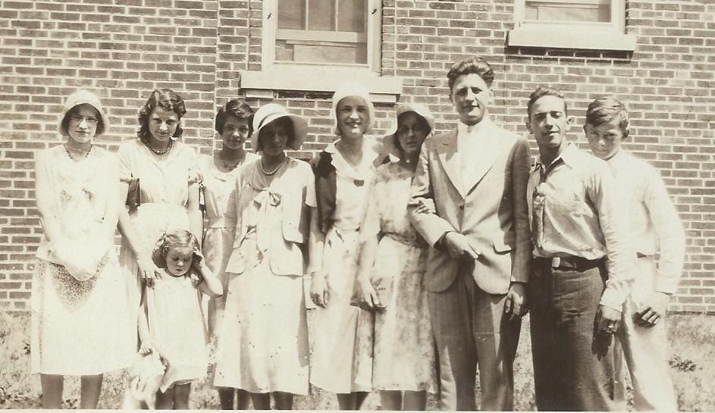
Fern was our oldest member, and at age 99 she has the distinction of being the longest standing member in the history of our congregation, and the first child that we have a record for baptism in our record book. She was born in 1916 in the middle of World War 1, when life in the small village of Mukwonago was very different from the way it is today. The first telephone poles had just gone up in 1903, the first sidewalks in 1908, although it would be years before most people had a phone, or a side walk in front of their homes. Our church was heated by a potbelly stove, and it would be four more years before women got the vote. When she was born, the United Unitarian and Universalist Society of Mukwonago, (UUUSM) was only 29 years old, and so her life has spanned most of our church history. She lived to see 30 ministers pass through our doors.
As an active member of UUUSM the important events in Fern’s life can be found recorded in the church record book. They Include:
- Fern Strickler born Nov 1, 1916 while Rev. Albert Altenborn was the minister at UUUSM
- Baptism Aug 12, 1917 by Rev J.S. Diem
- May 27, 1932 Fern Bertha Rintelman became a member
UUU Sunday School Class circa 1930. L to R Lois Durant Bisset, Ruth Rintelman Kern, child Betty Davis, Fern Rintelman Strickler, Mabel Lancaster, Janis Grutzmacher Ericksen, Viola Richold Nelsen, Melvin Hiller, Alfa Hinz,
Bill Rust

- Aug 24, 1940 Fern Rintelman married William Strickler.
- Her father Ernest Rintelman died Nov 9, 1954
- Her mother Jessie Rintelman died April 21, 1964
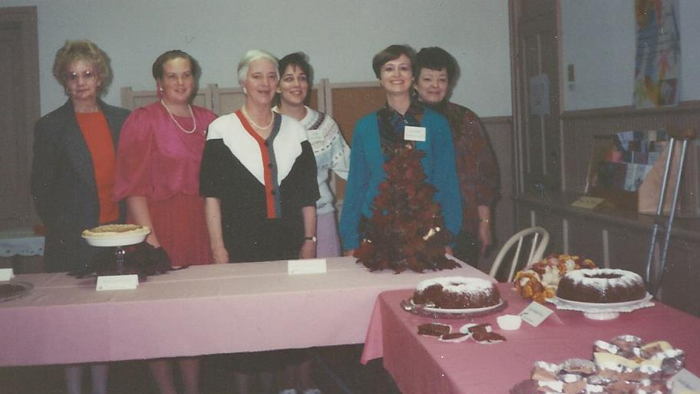
Fern’s parents were also members of UUUSM, although interestingly the Record Book lists them as becoming members in 1940 when Rev. J. Stewart Diem was minister. We do know that her father, Ernest Rintelman served on the board, and as board president in the 1940’s, and that the brass plates that we use for our collections each Sunday were donated by the Rintelman and Erichsen families.
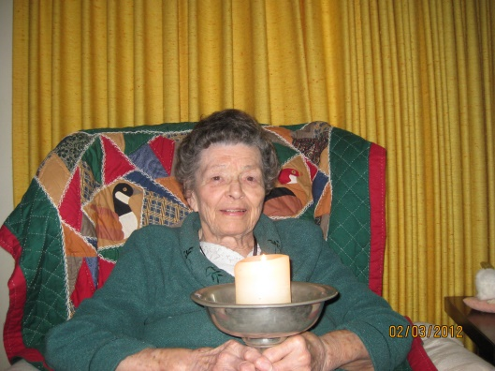
Fern who was the oldest of the three Rintelman sisters was involved in church from her early years, attending Sunday school with her sisters Charlotte and Loraine until she joined the congregation when she was fifteen. Fern was an active and influential member of our congregation. She could always be found in the kitchen, and was especially involved in organizing meals and potlucks at church. She was also involved in cooking the meals for the Kiwanis Club who met weekly in the upstairs meeting room. The meals were cooked in the downstairs kitchen and delivered upstairs by a pulley system. Fern’s daughter Gail describes her mother as being ambitious. She was certainly a great organizer and our church was lucky to have her in our congregation. Over the years Fern faithfully attended Sunday services, but after we moved from our Church on Main Street in Mukwonago, health issues made it difficult for her to attend.
1993 Organizing the Chocolate Fantasy Fundraiser
L to R Ann Hetherington, Bonnie Davel, Charlotte Simpson,
Lisa Keating, Jeanne Milliren and Fern Strickler

It was just over a year ago that Fern helped me identify some people in our photograph albums. I will miss not having her to help me figure these things out, as she was the only person that I could talk to about the early history of our congregation. She was the kind of person who rarely gets recognized, and we will miss this quiet, capable, organizer who worked tirelessly behind the scenes, to make life a little bit more enjoyable for the rest of us

Rev. Schuyler Vogel, Remembers Fern Strickler
Sunday 15, 2015 Service
It is with a heavy heart that I share with you that a long time member of our congregation, Fern Strickler, passed away this week. While she had spent the last year in the Linden Grove care facility in Mukwonago, I had the pleasure of meeting with her and was impressed immediately by her warm and generous spirit. She was a truly remarkable woman, a member of this congregation for 99 years, along with her two sisters, Charlotte and Loraine. Together, they grew up at United, went to religious education, graduated and in turn raised families of their own. Fern would take charge of coffee hour and food, and would serve there for years, becoming known as “the patron saint of our kitchen.” In all Fern was the steady and dedicated rock of our community for almost a full century. Through her love and devotion, Fern made this congregation the welcoming and beautiful place we now cherish and we are grateful for her life. Let us take a moment of silence to honor her memory.

