ComUUnicator
Bringing you the news of the United Unitarian Universalist Congregation
Waukesha, Wisconsin
April 2016
506 N. Washington Avenue  Waukesha, WI 53188  262-544-1050  www.UnitedUUC.org |  | 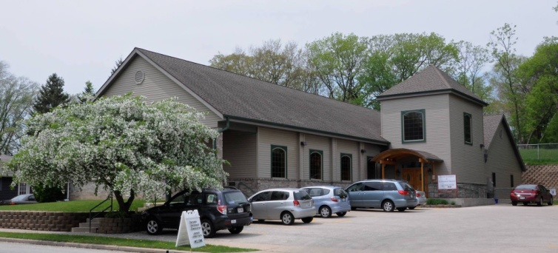 |  | OFFICE HOURS  Tuesday & Friday  9am – 3pm  MINISTER’S HOURS  Tuesday 10am-12pm  Friday 10am – 2:00 pm
United Worship Services
Every Sunday at 10:30 AM

April 3, 2016 “Touch the Earth" Guest Speaker: Rev. Lori Hlaban
The act of creation is often relegated to God, and assumed to have been completed long ago. In this service we'll explore some alternative (yet theological) ways of thinking about creation.

April 10, 2016 “Is is Good?” Speaker: Rev. Schuyler Vogel

Art and religion have a long and complicated history together. Sometimes they inspire and reinforce each other, other times they oppose and condemn. The two have much in common and yet can have fundamentally different objectives. We will explore that relationship today and the difficult questions it poses: of moral responsibility, of freedom of expression, of what is worthy of our creation and admiration.

April 17, 2016 “The Earth is Fine” Speaker: Rev. Schuyler Vogel
Over billions of the years, the earth has survived catastrophe after catastrophe. As it faces calamity from irresponsible human activity, we can rest peacefully knowing that the earth will be fine. Rather, it’s us I’m worried about. Climate scientists are forecasting large scale global consequences that threaten our very survival. How do we respond, both practically and emotionally to these doom day predications?
April 24, 2016 “Flunking Sainthood” Guest Speaker: Rev. Dr. Bobbie Groth
Through the ages religions have proposed regimens of self-discipline for adherents, often elevating those who manage to dedicate their lives to such things. Does self-discipline enter into UU spirituality at all? How, why, in what forms, and for what purposes does it have meaning for us? Can we aspire to sainthood?
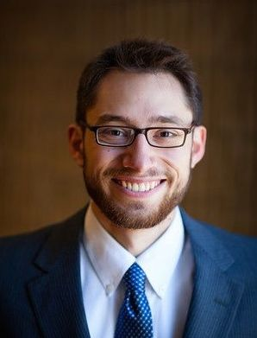 | Rev. Schuyler Vogel  minister@uniteduuc.org  262-544-1050 |  | Office hours  Tuesday 10am to 12pm  &  Friday 10am to 2pm

TREASURER’S REPORT
TREASURER'S REPORT for 2015-16 Fiscal Year
Income |  | Amounts from |  | Amount Budgeted for the
 |  | 7/1/15 - 03/22/16 |  | Year 7/1/15- 6/30/16
 | Pledges | $45,717 |  | $69,350
 | Other Income | $21,881 |  | $41,666
 | Total Income | $67,598 |  | $111,016
Total Expenses |  | 75,718 |  | $104,484
Income - Expenses |  | ($8,120) |  | $6,532
Endowment Balance on 03/22/16 is $197,723
Mortgage Balance on 03/01/16 is $145,194

United’s 13th Annual Auction
Saturday, April 23 starting at 6PM
506 N Washington Ave, Waukesha, WI

Friends, Romans, countrymen - please mark your calendars for
United's "Mid-Spring Night's Auction"
This year's theme centers on William Shakespeare to celebrate his life and work.
Angela B. will again be our auctioneer, mistress of ceremonies and great source of entertainment
Schedule for the night’s events:
6-7pm - Dessert sale and item viewing
6-8:15pm Silent Auction
7-8:30pm Live Auction
8:30pm Approximate time of check out

Remember, our annual auction is a BYOB, beer and wine only, please. This is a great night to have some fun, bid on amazing items and to support our UU community!
SOCIAL ACTIONS COMMITTEE NEWS

April Food Pantry collection – April 3
For the month of April, we are focusing on donations of
Cereals – both hot and cold varieties

Of course your generous donations of any food and personal care items are more than appreciated! Thank you!!

SAVE THE DATE TO SAVE A LIFE
United's Annual Blood Drive will be held in the sanctuary on Monday, May 23 from 3-7pm. Appointments will be available and walk ins are welcome! Please let your family and friends know about this important event for our community.

Threads United will meet on April 6 & 20 at 9:30am
Threads United is a group which was formed by the Social Action Committee. The goal of our group is not only to create quilts and any type of stitched items to be donated to children in need, but equally important and rewarding is to create a bond between our members.

We meet the first and third Wednesdays of each month, including the summer, at Marcia Romashko's home from 9:30 a.m. to about 2:30 p.m. with a break for lunch.
Threads is a very relaxed group, so you don't have to know how to quilt or stitch because everyone is willing to help you learn.......just come join us! For more information, please feel free to contact Marcia at 262-968-4636 or owasseh@yahoo.com.
The Zen Path

In the last Zen path session we discussed suffering and how to reduce or eliminate suffering in our lives (Buddha's first teaching). Next month's session will be held from 7:00pm to 8:00pm on Thursday April 14th and we will look at Karma - what is it, what does it mean for us, and how does it affect our future. We'll also look at good karma versus bad karma and how it affects us as well as others. Please join us for an interesting discussion on karma and bring your Buddhist/Zen questions for the question and answer period following the discussion.

May 2016 Newsletter Deadline
April 22, 2015
All report & articles must be UU related

APRIL POTLUCK- Sunday April 10
This month’s potluck is “Mexican Fiesta”
Please see the sign-up sheet in the Fellowship hall or contact Kaye W at kwickenberg@wi.rr.com for information and to see what is needed.
Guest speaker at United, April 17 at 12PM
Dr. Bruce Wilson, currently Associate Medical Director at Zilber Family Hospice in Milwaukee, will speak at United after services on End of Life issues and decisions. He will clarify commonly used term and services and discuss Aid in Dying legislation that has recently passed in California and is on the legislative agenda in more than 20 additional states.

Public Hearing announcement
Waukesha County Health & Human Services Board invites you to comment on the quality of health and human services programs, unmet needs and improvements that could be made in the current system of Health and Human Services in Waukesha County. Your concerns and recommendations will be considered by Health and Human Services board members and staff as the 2017 Department of Health and Human Services budget is prepared for the County Executive.
PUBLIC HEARING
Thursday, April 7, 2016 at 7:00PM
Waukesha County Health and Human Services Public Health Department
514 Riverview Ave. Waukesha, WI
It will be helpful for speakers to prepare a written statement to give to the Chair which is summarized at the hearing. If you are unable to attend the hearing, you may communicate with us in writing:
LETTERS
by April 8, 2016
Write to
Donna Ferguson, Public Hearing Coordinator
Waukesha County Department of Health and Human Services
514 Riverview Ave. Waukesha, WI 53188-3631
Persons in need of assistance
Hearing impairment: Call Human Service TDD at 548-7311 no later than March 22
Specialized transportation for eligible individuals: Call 262-548-7848 by March 22.
In need of a language interpreter: Call Donna Ferguson at 262-548-7383 or email dmferguson@waukeshacounty.gov by March 22.
Note: A quorum of the County Board and/or its Committees may be in attendance, for purpose of observing and gathering information but not for the purpose of conducting business or taking action.

UU Buddhist Study Group
An ongoing program and outreach offering for those interested in learning about Buddhist teachings and practices continues to be offered at the Mukwonago Linden Grove campus, 837 County Road NN. The Buddhist Study group meets twice monthly on the 1st and 3rd Wednesdays of the month from 6:30-8:00pm
We share a reading aloud during each meeting, and we share our thoughts and questions related to the book we agree to read outside of the meetings. We take an informal approach to study and learn through one another’s perspectives. We welcome anyone who has an interest, whether they have chosen to read along or just come to converse. We include a seated meditation, typically silent but on occasion instead a guided meditation or a walking meditation.
If you would like to have occasional email updates regarding the group, contact the United UUC office at uniteduuc@gmail.com to add your name to the uubuddha list. Those with questions can contact Patti Kies at kiespa24@alumni.uww.edu
Dates to remember in April
April 3 – Food Pantry Collection – Cereals, hot and cold
April 6 & 20 at 9:30AM – Threads United, meets at Marcia’s
April 6 & 20 at 6:30PM – Buddhist Study Group, meets at Mukwonago Linden Grove
April 10 at 11:45AM – Potluck Mexican Fiesta
April 14 at 7PM - The Zen Path
April 17 at 12PM – Guest speaker: Dr. Bruce Wilson, MD
April 19 at 4PM – Coffee with the Minister meets at Steaming Cup, Waukesha
April 19 at 6PM - Soul Matters
April 20 at 4PM – United Board Meeting
April 22 - May newsletter deadline
April 23 at 6PM – United’s 13th Annual Auction
April 24 at 11:45AM – Social Actions Committee meeting
Nicaragua Brigades
This summer, volunteers from UU Church West in Brookfield (and possibly other churches) will once again travel to Nicaragua to build houses and community with our Nicaraguan neighbors.
The church has been organizing “Brigadistas” to travel every other year since 2004. During these ten-day trips,
together with partner organization, Bridges to Community, church members build houses for and with families in rural communities. Over the past 11 years, 159 of UUCW members and friends from age 14-78 have joined! Openings are available on the July 8-17 trip to Masaya, Nicaragua. Please contact Jim Fischer: (262) 860-0240 or gleesonfischer@sbcglobal.net
WEATHER CLOSINGS
Spring is here, but remember that it’s still possible to cancel services due to bad weather on occasion. If this should occur, United is linked to WTMJ and WISN to inform you if we are open or closed for worship. If you have any questions about closures, please check with tmj4.com or WISN.com
SUNDAY GREETERS AND COFFEE HOSTS
Greeters | Coffee Hosts
4/3 Sara T & Faye F  4/10 Ann M & Kylee S  4/17 Jenny M, Doug & Betty C  4/24 Geoff B & Ellen P | 4/3 Herb & Dona L and Jenny M  4/10 POTLUCK  4/17 Kylee S, Darlyn B, Peggy L & Tudy B  4/24 Kathy W & Mike Z
**Please remember, if you cannot be at church on your scheduled day, please find a replacement and then let the office know.

